**Exploring Paracetamol Pharmaceutical Production**

**Course Title: Industrial Assignment**



**A**

**Reasearch Paper**

**Submitted to the Department of Chemistry in Partial Fulfillment of the Requirements for the Bachelor of Science Degree in Chemistry.**

**Submitted By**

**Exam Roll: CHE 017/4**

**Session: 2020-2021**

**Registration No: 151-045-18**

**8-6-2023**

**Department of Chemistry**

**University of Barishal**

**Kornokathi, Barishal 8254**

Abstract

Unveiling the Mechanical Journey of Paracetamol: From Raw Materials to Finished Tablets. Navigating Quality Standards and Equipment in Paracetamol Pharmaceutical Production.

1 Introduction 4

1.1 General Remarks 4

1.2 Objective of Research 4

2 Review of Literature 5

2.1 Previous Research on Isatin-Derived Compounds 5

2.2 Significance of the Current Study 5

3 Synthesis 6

3.1 Synthesis of Paracetamol (RN-1) 6

4 Results and Discussion 7

4.1 Mannich Base Synthesis (RN-1) 7

5 Applications 8

6 Conclusion 9

7 References 10

Table of Figures

Figure 1: Formation of Mannich Base 7

Figure 2: RN-1 8

Figure 3: Application of compounds. 9

# Introduction

## General Remarks

The word “Pharmacy” is the combination of the Greek term “pharmakon” (magic, charm, cure, potion, medicine) and the Latin term “pharmacie”. Pharmacy is the science and practice of discovering, producing, preparing, dispensing, reviewing and monitoring medications, aiming to ensure the safe, effective, and affordable use of medicines. It is a miscellaneous science as it links health sciences with pharmaceutical sciences and natural sciences. The professional practice is becoming more clinically oriented as most of the drugs are now manufactured by pharmaceutical industries.

## Objective of Research

Paracetamol (or acetaminophen) is a common analgesic, a drug that is used to relieve pain. It can also be used to reduce fever, and some kinds of headache. This makes it an antipyretic, something that reduces fevers. It is used in many drugs that treat the flu and colds. The words acetaminophen and paracetamol both come from the names of the chemicals used in the compound: N-acetyl-para-aminophenol and para-acetyl-amino-phenol. Sometimes, it is shortened to APAP, for N-acetyl-para-aminophenol. Paracetamol (acetaminophen) is undoubtedly one of the most widely used drugs worldwide. As an over-the-counter medication, paracetamol is the standard and first-line treatment for fever and acute pain and is believed to remain so for many years to come. Despite being in clinical use for over a century, the precise mechanism of action of this familiar drug remains a mystery. The chemical properties of paracetamol are given below-

Chemical Formula: C8H9NO2

Melting point: 169 °C

Boiling point: 420 °C

# Review of Literature

## Previous Research on Isatin-Derived Compounds

The exploration of isatin derivatives in previous research has laid a solid foundation for understanding their synthetic accessibility and diverse chemical reactivity. Early studies focused on fundamental methodologies involving the condensation of isatin with various nucleophiles, leading to the formation of substituted isatins. These derivatives have been investigated for their unique chemical properties and potential applications.

## Significance of the Current Study

Pharmaceutical industry is the discovery, development, and manufacture of drugs and medications (pharmaceuticals) by public and private organizations. It is a vast and complex sector that plays a critical role in global healthcare by researching, developing, manufacturing, and distributing medications to prevent, treat, and cure various diseases and medical conditions. This industry encompasses a broad range of activities, including drug discovery, clinical trials, regulatory approval processes, and commercialization. These pharmaceutical products are designed to diagnose, prevent, treat, or cure various medical conditions and diseases in humans. The industry plays a pivotal role in advancing healthcare by bringing new drugs to the market, improving existing treatments, and contributing to medical research.

The pharmaceutical industry in Bangladesh has experienced substantial growth over the past few decades and has become a significant player in the global pharmaceutical market. The sector has evolved from primarily producing generic drugs for the domestic market to exporting pharmaceutical products to various countries around the world. The pharmaceutical industry in Bangladesh is one of the most developed technology sectors within the country. Manufacturers produce insulin, hormones, and cancer drugs. This sector provides 97% of the total medicinal requirement of the local market. The industry also exports medicines to global markets, including Europe. Pharmaceutical companies are expanding their business with the aim to expand the export market.

# Synthesis

## Synthesis of Paracetamol (RN-1)

IUPAC ID: N-(4-hydroxyphenyl)acetamide, N-(4-hydroxyphenyl)ethanamide

Soluble in: Water, Acetone.

Structure of paracetamol:

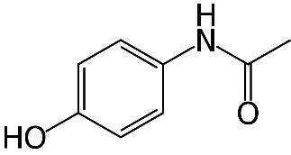

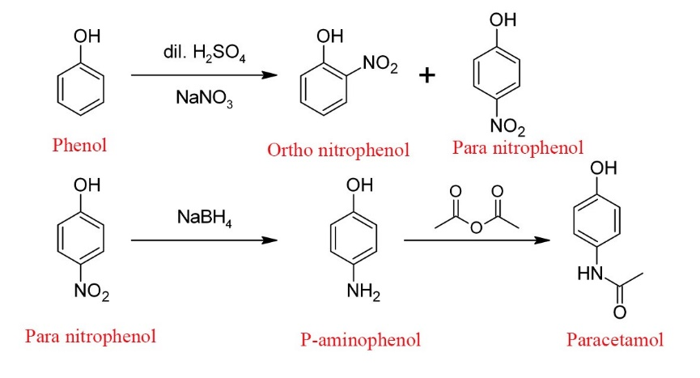

Figure 1: Formation of Paracetamol

# Results and Discussion

## Mannich Base Synthesis (RN-1)

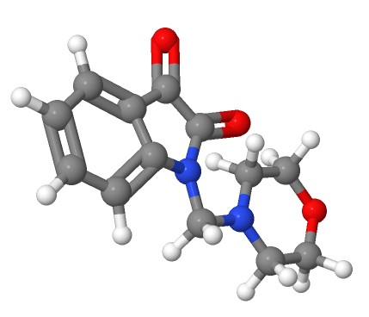The Mannich base (RN-1) was successfully synthesized through the reflux reaction of isatin and morpholine in methanol, facilitated by formaldehyde. The reaction proceeded for 3.5 hours at 100°C, resulting in a refined product with a satisfactory yield of 70.07%. The use of methanol as a solvent and recrystallization contributed to the purification of RN-1.

Figure : RN-1

# Applications

Paracetamol, also known as acetaminophen, is widely used for relieving mild to moderate pain such as headaches, muscle aches, menstrual cramps, toothaches, and minor arthritis pain, as well as for reducing fever. It is often included in combination therapies with other analgesics or decongestants in cold and flu remedies and can be used for postoperative pain management. Available in various forms, including oral, rectal, and intravenous, paracetamol is generally safe when taken as directed but requires caution due to the risk of liver toxicity in cases of overdose or chronic heavy use.

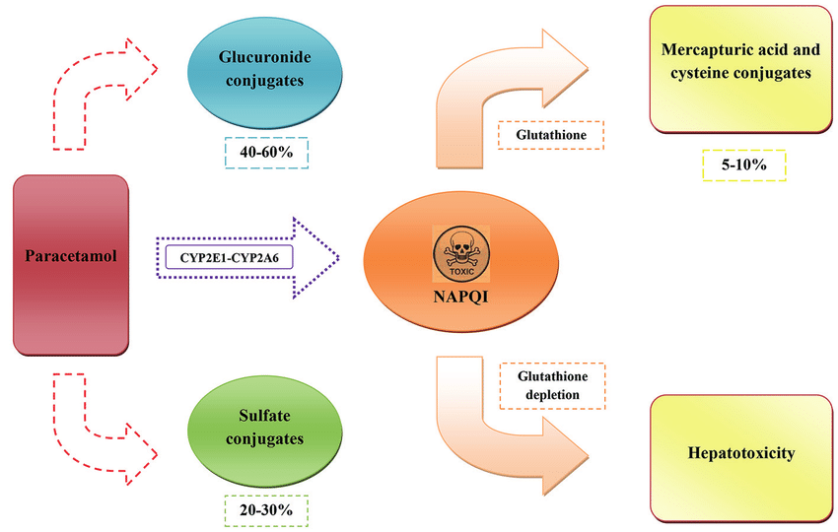

Figure 3: Application of compounds.

# Conclusion

We are thankful to our for faculties for organizing such an informative event for us in crucial to develop our practical skills regarding logistics and documentation or other managerial activities.

We hope we get more chances further to have such wonderful and informative experiences of visiting different industries.

# References

|  |  |
| --- | --- |
| [1] | G. Wang, M. Chen, J. Qiu, Z. Xie and A. Cao, "Synthesis, in vitro α-glucosidase inhibitory activity and docking studies of novel chromone-isatin derivatives," *Bioorganic & Medicinal Chemistry Letters,* vol. 18, no. 2, pp. 113-116, 2018. |
| [2] | H. S. Ibrahim, S. M. Abou-Seri, M. Tanc, M. M. Elaasser, H. A. Abdel-Aziz and C. T. Supuran, "Isatin-pyrazole benzenesulfonamide hybrids potently inhibit tumor-associated carbonic anhydrase isoforms IX and XII," *European Journal of Medicinal Chemistry,,* vol. 103, pp. 583-593, 2015. |
| [3] | X.-M. Zhang, H. Guo, Z.-S. Li, F.-H. Song, W.-M. Wang, H.-Q. Dai, L.-X. Zhang and J.-G. Wang, "Synthesis and evaluation of isatin-β-thiosemicarbazones as novel agents against antibiotic-resistant Gram-positive bacterial species," *European Journal of Medicinal Chemistry,* vol. 101, pp. 419-430, 2015. |
| [4] | N. D. Thanh, N. T. K. Giang, T. H. Quyen, D. T. Huong and V. N. Toan, "Synthesis and evaluation of in vivo antioxidant, in vitro antibacterial, MRSA and antifungal activity of novel substituted isatin N-(2,3,4,6-tetra-O-acetyl-β-d-glucopyranosyl)thiosemicarbazones," *European Journal of Medicinal Chemistry,* vol. 123, pp. 532-543, 2016. |
| [5] | B. A. P. Y. D. S. Tanushree Ratan Bal, "Synthesis and evaluation of anti-HIV activity of isatin β-thiosemicarbazone derivatives," *Bioorganic & Medicinal Chemistry Letters,* vol. 15, no. 10, pp. 4451-4455, 2005. |
| [6] | Z. Xu, S. Zhang, C. Gao, F. Zhao, Z.-S. Lv and L.-S. Feng, "Isatin hybrids and their anti-tuberculosis activity," *Chinese Chemical Letters,* vol. 28, no. 2, pp. 159-167, 2017. |

|  |  |
| --- | --- |
| [7] | H. Bagum, M. A. Hossain, M. AL-AMIN and M. R. Islam, "SYNTHESIS AND CHARACTERIZATION OF A SERIES OF MANNICH BASES AS CYTOTOXIC AGENTS," *Journal of Bangladesh Chemical Society,* vol. 26, no. 1, pp. 93-99, 2013. |
| [8] | A. Singh, H. Kaur, S. Arora and P. M. S. Bedi, "Design, synthesis, and biological evaluation of novel morpholinated isatin–quinoline hybrids as potent anti-breast cancer agents.," *Archiv der Pharmazie,* vol. 355, no. 2, 2022. |